🌀 TBS-CC OKRs 4.6 DevOps 🌀

The Modern Software Engineering route to OKRs 4.6 DevOps
20.16z9) The Modern Software Engineering Route to OKRs 4.6 DevOps (17 Dec 2023)
By Nick Ray Ball

Sunday – 12:13 GMT – Dec 17, 2023

TBS-CC OKRs 4.6 DevOps

Featuring/Inspired by:

Modern Software Engineering: Doing What Works to Build Better Software Faster

Chapter 3 Fundamentals of an Engineering Approach.

Written by David Farley, narrated by Amy Gordon

@ 4.54 minutes

“The valuable work carried out by Nicole Forsgren, Jez Humble and Gene Kim in The State Of DevOps Reports and their book Accelerate: The Science of Lean Software and DevOps, represents an important step forward in being able to make stronger more evidence-based decisions, they present an interesting and compelling model for the useful measurement of the performance of software teams. Interestingly they don't attempt to measure productivity, rather they evaluate the effectiveness of software development teams based on two key attributes. The measures are then used as part of a predictive model. They cannot prove that these measures have a causal relationship with the performance of software development teams, but they can demonstrate A statistical correlation.
The measures are stability and throughput.
Teams with high stability and high throughput are classified as high performers, while teams with low scores against these measures are low performers. The interesting part is that if you analyse the activities of these high and low-performing groups they are consistently correlated. High-performing teams share common behaviours, equally, if we look at the activities and behaviours of a team, we can predict their score against these measures, and it too is correlated. Some activities can be used to predict performance on this scale. For example, if your team employs test automation, trunk-based development, deployment automation and about 10 other practices their model predicts that you will be practising continuous delivery.
If you practise continuous delivery the model predicts that you will be high-performing in terms of software delivery performance and organisational performance. Alternatively, if we look at organisations that are seen as high performers then there are common behaviours – such as continuous delivery and being organised into small teams that they share.

Measures of stability and throughput then, give us a model that we can use to predict team outcomes, stability and throughput are each tracked by two measures.
Stability is tracked by the following, change failure rate – the rate at which a change introduces A defect at a particular point in the process. Recovery failure time – how long to recover from a failure at a particular point to process.
Measuring stability is important because it really is a measure of the quality of work done, it doesn't say anything about whether the team is building the right things, but it does measure their effectiveness in delivering software with measurable quality.

Throughput is tracked by the following – lead time a measure of the efficiency of the development process, how long for a single line change to go from idea to working software, and frequency, a measure of speed. how often are changes deployed into production?
throughput is a measure of a team's efficiency at delivering ideas in the form of working software. How long does it take to get a change into the hands of users and how often is that achieved? This is among other things an indication of a team's opportunities to learn.
A team may not take those opportunities, but without a good score and throughput any team's chance of learning is reduced, these are technical measures of our development approach they answered the questions of what the quality of our work is and how efficiently can we produce work of that quality. These are meaningful ideas, but they leave some gaps, they don't say anything about whether we're building the right things, only if we're building them right. But just because they aren't perfect does not diminish their utility.
Interestingly the correlative model that I described goes further than predicting team size and whether you are applying continuous delivery, the Accelerate authors have data that shows significant correlations with much more important things.
For example, organisations made up of high-performing teams based on this model make more money than organizations that don't.
Here is data that says there is a correlation between a development approach and the commercial outcome for the company that practises it. it also goes on to dispel a commonly held belief that you can either have speed or quality but not both. this is simply not true speed and quality are clearly correlated in the data from this research:

The route to speed is high-quality software, the route to high-quality software is speed of feedback, and the route to both is great engineering.”

Part 1 Reply. Fundamentals of S-Web & OKRs

by Nick Ray Ball

This morning I woke up and listened to chapter 3. Fundamentals of an Engineering Approach.
My ears pricked up when I heard the mention of DevOps, a skill that I have some natural talent for and some real-world small-scale experience, but no education.
Recently I've looked back at the failed 2009 experience Africa S-Web 2. And firmly put that down to that at that time I was not in the same role as both developer and operational leader as I had been with the virtual successes from 2000 to 2004 and cloud software CMS S-Web 1 from 2002 to 2007.

So, I continue to listen up until the line; “The route to speed is high-quality software, the route to high-quality software is speed of feedback, and the route to both is great engineering.”

At this point, I strongly believe the T2 TBS-CC OKRs 4.5 design as it currently stands, plus the Quanta Analytica, would be something that Nicole Forsgren, Jez Humble and Gene Kim would appreciate strongly.
And if they would appreciate that, they would appreciate S-Web and the entire 10 technologies design.
As much because it is from somebody who has had no education, other than being thrown into the role of DevOps without knowing the role existed between 2000 and 2016.
I recently created a DevOps category [20.12] and there is, of course, the OKRs category [20.18] both of which I was tempted to add this document to, but because of the momentum the [20.16] S-Web 6 VC category has built, particularly in terms of the software engineering, I decided to keep it in series, but copy the ID, in the lighter grey print within the index for [20.12] and [20.18]

“One book has opened the door to an entire hemisphere of study.”
Exactly where I go from here, is an open road, similar to when I started to study theoretical physics, then economics, then business studies, “one book has opened the door to an entire hemisphere of study.”
I'm very tempted to present to Nicole Forsgren, Jez Humble and Gene Kim who seem relatively contactable. I do need a DevOps specialist to guide my software engineering choices, from Microservices to adapting DevOps in practice two the TBS CC OKRs design, to the which AI first question? and the question of whether we create different microservices with different AIs, and is my microservices model, in the way I've currently described it in terms of we are making a CMS not dissimilar to WordPress just a lot simpler, so it can be operated per vocal commands, without using your hands, we then create microservices as a plugin’s.

It's as simple as that, said the blind man.
Is this the best model? well, the book I quoted at the beginning isn't the book that presents that model, but it does come to that kind of logic later in the book and I guess we'll have to wait and see.
In terms of adding the microservice cluster that is T2. OKRs, I am more confident about how useful the TBS CC OKRs 4.5 design is for software development. It was designed for my small software development team but evolved into a behavioural economic tool to 10x my productivity. The 4.5 design was established as a sales adaptation for www.CapeVillas.com, per the UCS Hawthorne design from 2018, and has now cascaded, to engaging with engineering rules to make a system that is so much fun due to that UCS gamification that software engineers will see it as a friend, not a time taking admin practice.
I’m even considering changing its name from OKRS 4.5 UCS to OKRs 4.5 DevOps.

After all, UCS is Technology Six and the combination of UCS into Technology 2, is already inherent in its design and has been for quite a while.
It would be good to have two designs in tandem, OKRs UCS which focuses on gamification, and DevOps which focuses on the kind of stuff that this book and the above-mentioned could contribute to greatly.
It might be a good idea to then consider the OKRs 4.5 UCS as the current model being designed, to create a later update maybe 4.6 or 4.7 as the DevOps addition that must be created before we start creating the large-scale software. Once I have better understood the different techniques within the DevOps skill set, and taken advice from the above-mentioned and the writers of this book and the Microservices book.

I am seriously considering, adding Nicole Forsgren, Jez Humble and Gene Kim As prime recipients, for the

S-Web and S-World presentations.

Even if they don't answer, writing to people who know what they're doing, raises the bar of the letter I would write.
The time for a dedicated TBS CC OKRs position in the prime menu of S-Web is long overdue. Before the microsystems plugin idea and the research into the relevant languages in which two write it, I had considered the TBS CC OKRs as a separate team-driven project that I would bind to S-Web in some way.
But as a team tool to motivate and reward developers, and create continuous feedback,

I now see both OKRs 4.5 UCS and OKRs 4.6 DevOps as essential parts of the initial design being prepared for Innovate UK et al.

Part 2. Microservices are Franchises ℏ🚀
[a work in progress]

Sunday – 14:36 GMT – Dec 17, 2023

I'm inspired to say some words, to Nicole, Jezz, Gene, David Farley, and Sam Newman author of Building Microservices.

I remember in the lecture A.W. Peet Public Lecture: String Theory Legos for Black Holes, two methods and different approaches to theoretical physics, came to the same conclusion, and when that happens it's significant.
I seem to have come to the same conclusions that you're teaching, so they seem natural, refined to pure complexity-saving measures, for which we could talk in theory for many hours about theories such as https://www.supereconomics.ai/book/2-4/super-coupling, which was the result of A.W’s lecture.

I can look back at all my work since 2011 and describe it in terms of complexity, but not specifically complexity within software, but rather the complexity within the entire economy. Which one can shape, in a way not dissimilar to Asimov’s psychohistory.

The Spartan Theory - Cities of Science [2011]
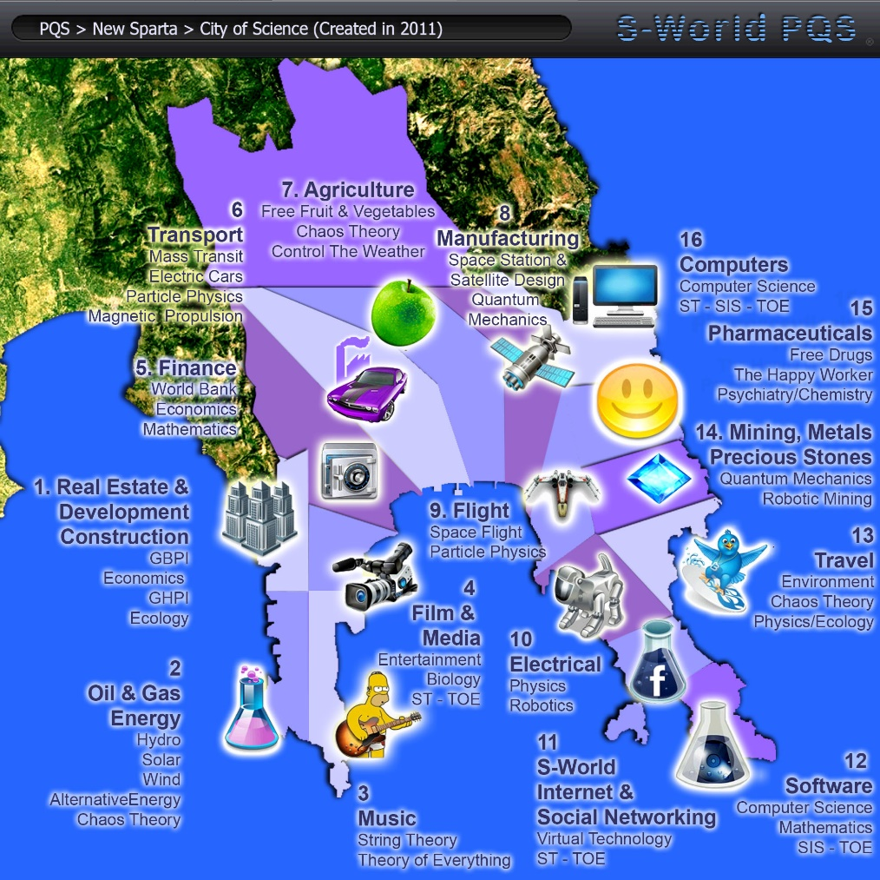

2012: The PQS – Predictive Quantum Software
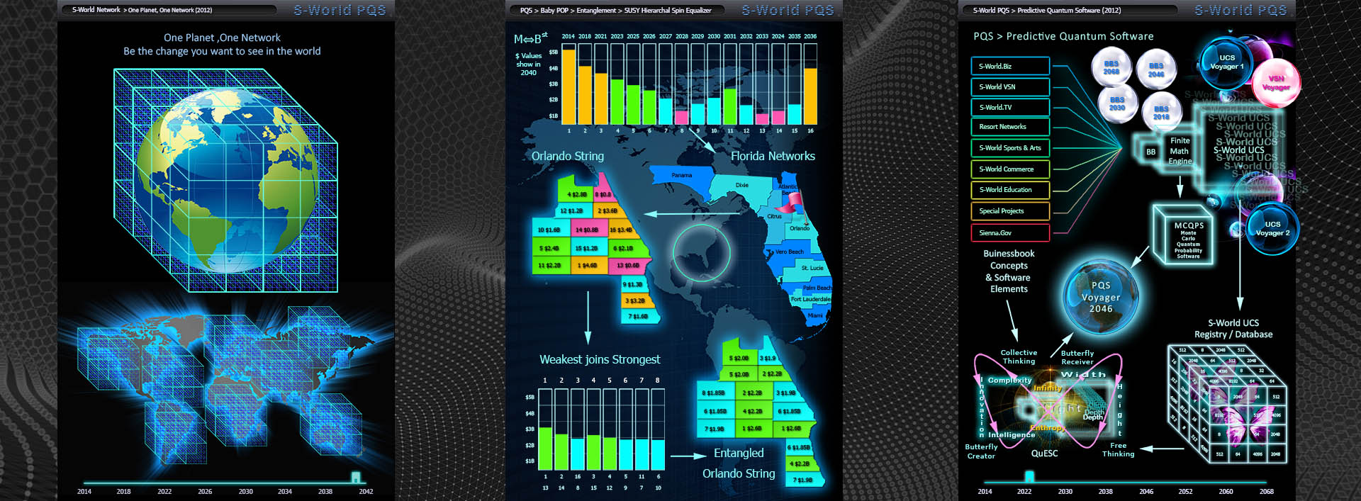

CRM Nudge AI [2017]

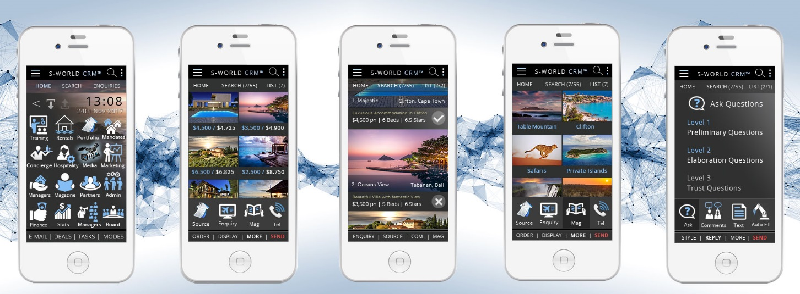

S-Web 3. Villa Secrets - 2013-2018

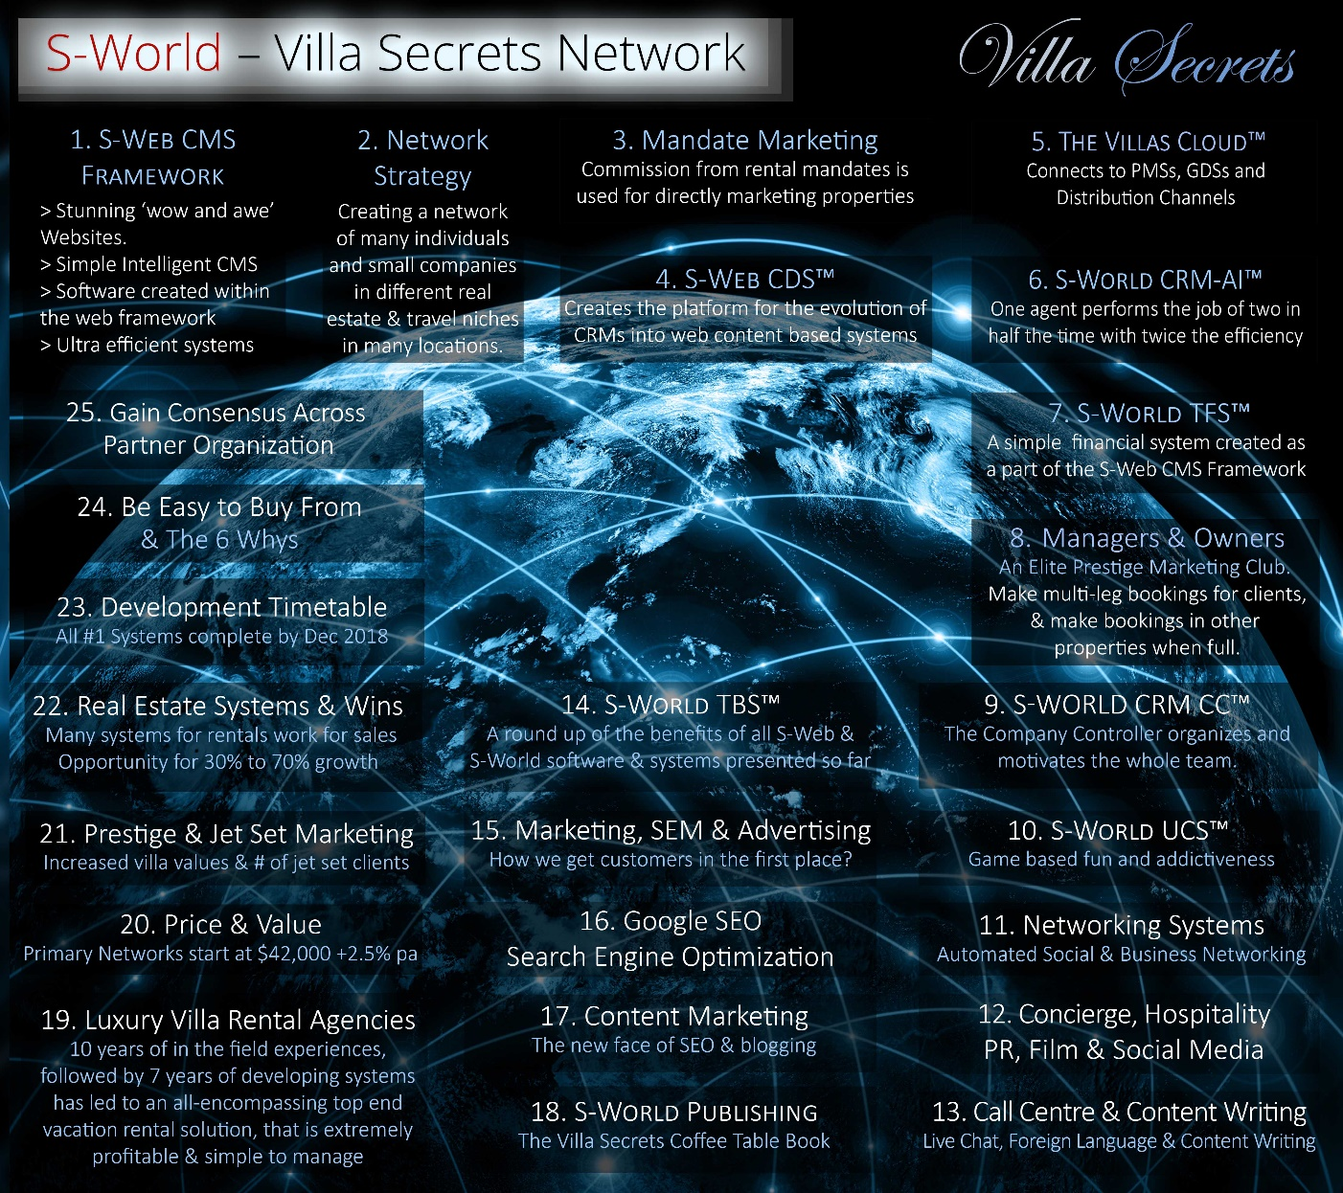

POP Financial Gravity [2011 to 2020]

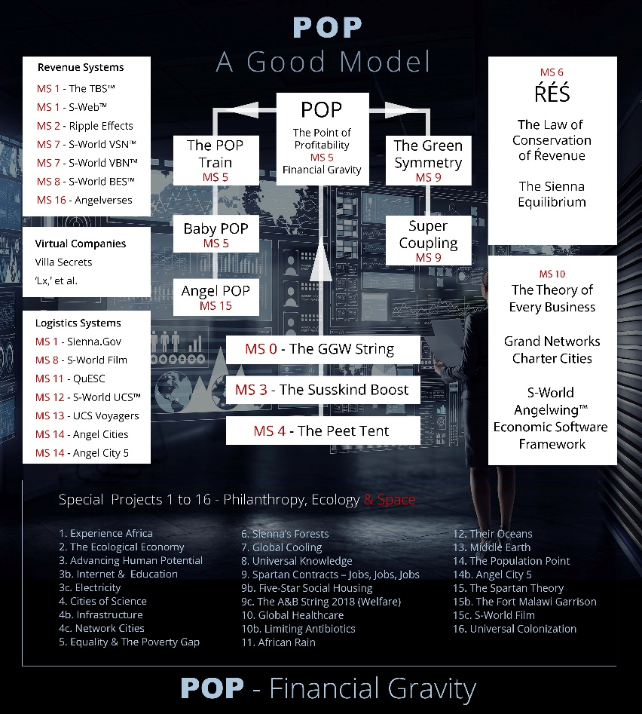
M-Systems [2017 to 2020]
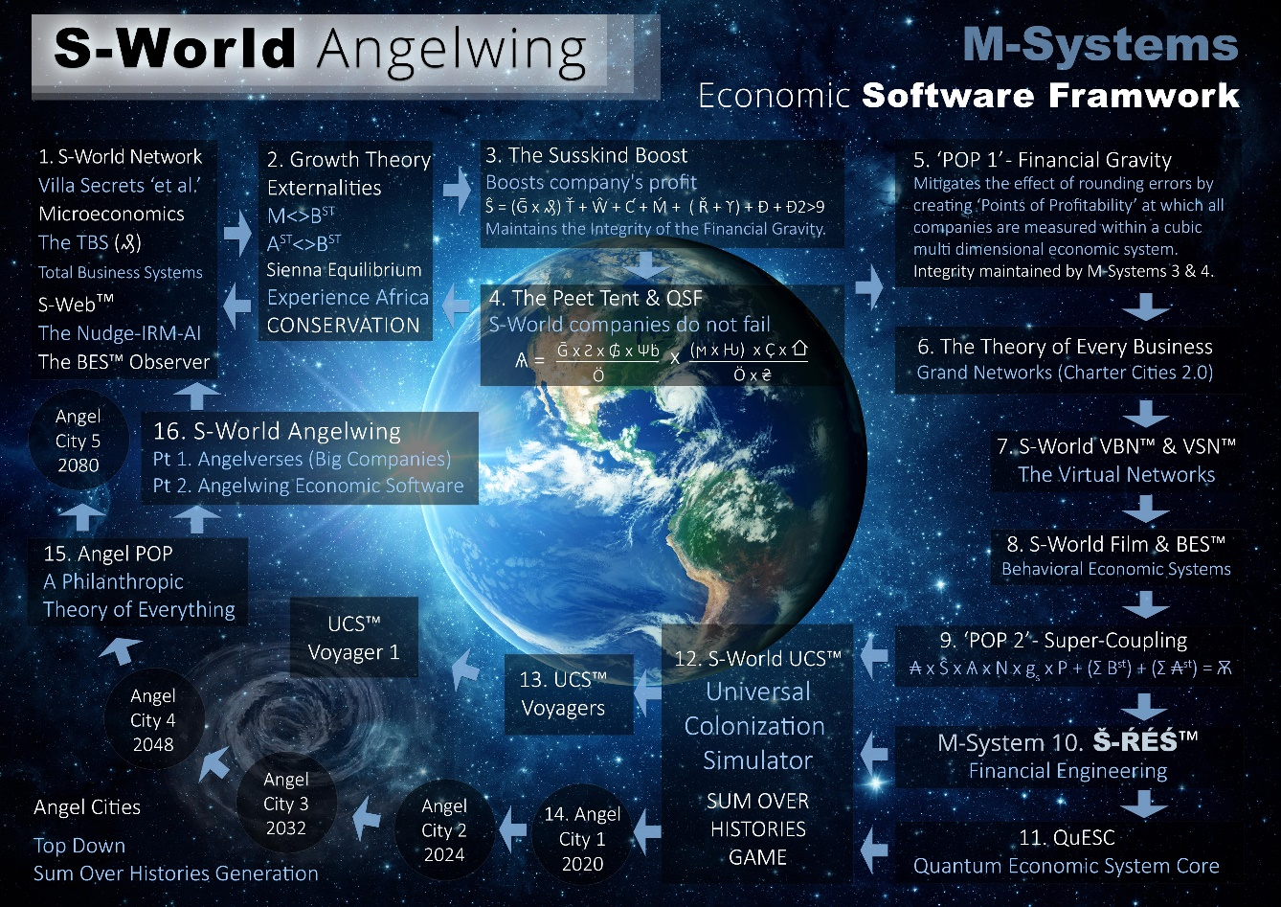

T7. S-RES Financial Engineering

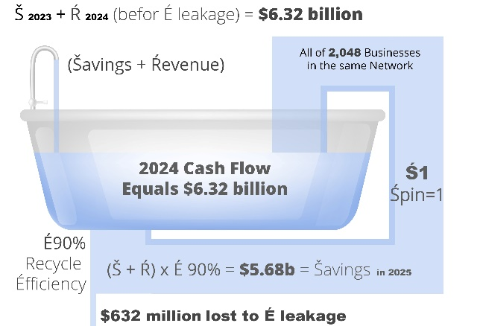
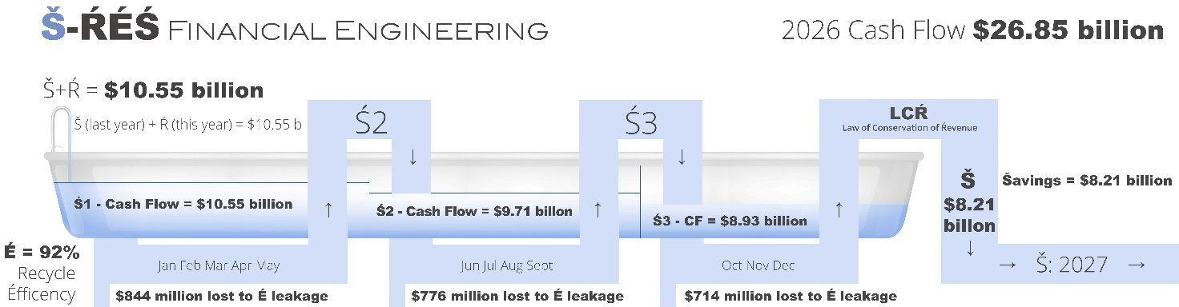

The 10 Technologies [2021 to 2024]
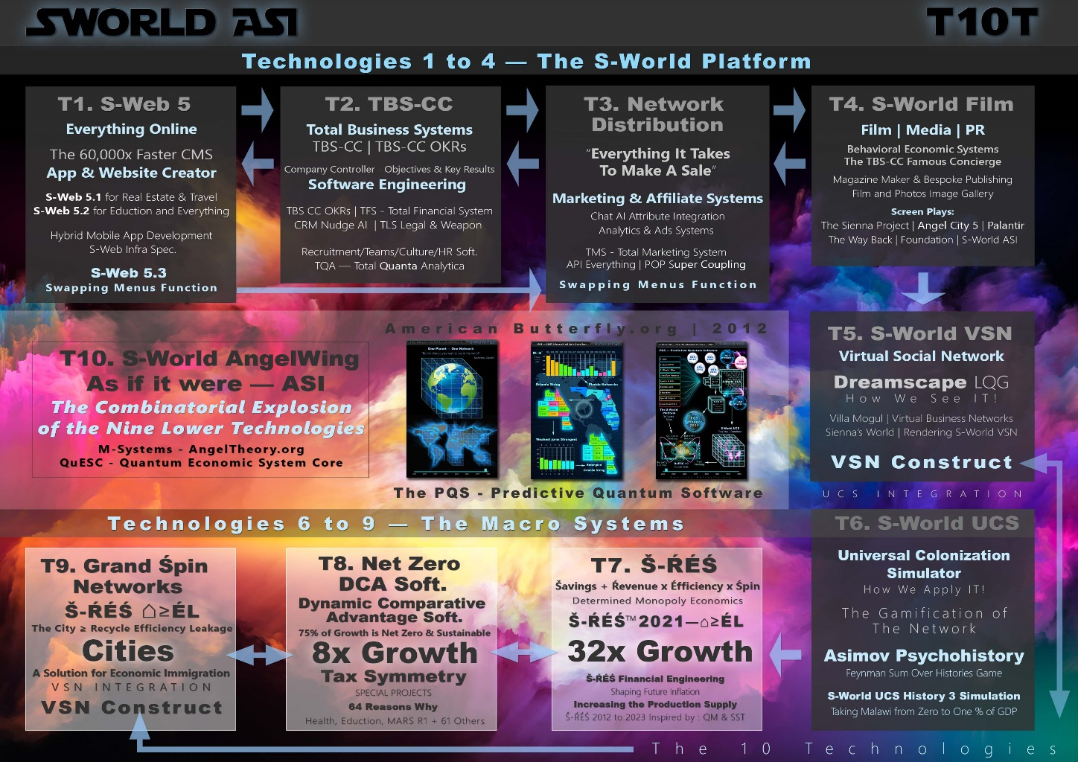
I have a theory about modern software engineering, that so far, is in agreement with everything Farley says, (remembering I’m only in the third chapter), and at the same time I now firmly believe that S-Web, which has become the foundational technology, and has for a long time wished to compete with WordPress for their 40% market share of the world's websites — that the microservices idea is akin to the different plugins you have in WordPress.
Each can be removed without another one failing, at least that's the objective.

The past few days in writing about my diminishing law a third-party software on API networks, led me to this design, where in place of creating a system that can adapt to all businesses, we just take the very essentials, needed for specific niches, and in so doing make the objective 1000x simpler.
Then in the same way Amazon went from selling books to selling CDs to selling everything, we adapt that one business system, in this case, the current prototypes are for luxury vacation rentals, and the second type is for luxury travel and safaris, which is akin to the jump from books to CD's, it didn't take a lot of re-engineering to change the system to a different product.

The keyword that I picked up in the book more than software, was complexity, managing complexity. By making specialists nice technologies for business cases, aiming at 0.1% to 0.5% of GDP at a time. Industry-by-industry good-by-good, service-by-service. It's not that it's 1000 times simpler, it is that because it is 1000 times simple it can be 1000 times better.

The best case I can present as an example of this is S-Web 6 VC.
We can see in S-Web 5.1 https://www.s-web.org/S-Web_60,000x_Videos.php, that by getting rid of the idea of individual widgets and replacing them with rows of content, with just eight rows of content, we can quickly build websites, see this example www.LuxGuides.com made in 51 seconds. https://www.youtube.com/watch?v=KytwOIMvMj8.

Because of this simplicity, it became entirely feasible, to rebuild or entangle with GPT4 or other LLM AI and make the entire process of building a website per voice command. Then just speak to the AI about the content of the website, and it'll write it out for you like a pro. Add pictures I know if you go.

From Desktop CMS Building To Mobile.
The transition from a computer to a mobile phone in terms of business was difficult for me, I was catching the curve in 2015, with the S-Web jQuery mobile, and the designs in 2016 and 2017 were mobile-first.
But I really couldn’t see a way to realistically make a mobile CMS, that one could use, for example, to give to a mandates networking sales agent, who could go to somebody’s villa, and right there and then speak to the owner and use the CMS on the phone to add their property to the website – show it to the owner – choose a domain name – click a button, and as soon as the DNS kicks in, suddenly there’s an individual website made of the house, with an easy as pie CMS for the actual owner of the property to play around with in the same way one might enjoy buildings one's house in the game THE SIMS.
We know from my experience from S web 1, owners love the ability to control their property on the web.
Even if they don't, if the agents have done all the work, it’s already done. It’s a two-step process, get the property listed online, which can be done by the agent, and keep that property listed from owner to owner, that is the job of S-Web.
But squeezing all that functionality into a mobile phone, and expecting people to tap the buttons and do it was unrealistic.

Sure in WordPress you can use it on the mobile phone and I’m sure there are probably people who can make websites in WordPress using their mobile phone quite quickly.
But not as quickly as they would be able to do on a desktop, so it’s not a skill anybody would practise much.
But by simplifying the process down to rows, not widgets, and because 99% of the time one is choosing other products to appear on their website using the T3 SWF Swapping Menus Function, which allows you to bring in an entire menu from another company.
Remember the real-world example when a https://www.capevillas.com client booked the $100,000 safari with https://www.experienceafrica.com and received $10,000 just for the referral.
That’s real life in a very small network, that’s the T3. Swapping Menu’s Function and you can imagine how popular it’s going to be.
Everybody who owns a villa or Airbnb holiday home can make their website using their phone, talking to it and wandering around the house, just describing the rooms and taking photographs that they go. Choose a domain and as soon as the DNS kicks in their websites live.

That’s the S-Web 6 VC🚀 Design.

They then add to their home, any other products and services from the network they want, and if anybody books any of those services, they make money. At the same time, the whole network is now got an incentive to book their villa.
It's not for everybody, maybe one in four Airbnb owners would try it out especially if it’s cool hip and trendy, has good branding, really plays up the game angle of it, plus of course when people start making money. And then people hear how easy it is to make money…
Suddenly introducing it to a network such as Sotheby’s International Realty, Airbnb or Instagram and the network effects can transform from one industry niche to virtually every industry niche.
One model we're working on is legal, The TLS [total legal system]and TLS-W, [total legal system weapon], but that’s essentially a plugin.
You can use it or not.
We can see if one of those networks has adopted S-Web, pretty much every service on the planet will have an interest in selling to that network. Especially as its simple as them choosing to add the menu portfolio and the AI will generally appear on the homepage, to recommend whenever the client discusses a service, if they want weddings – put in the weddings plugin, if they want safaris – it’s the safari plugin.
Each plugin is a microservice, a version of S-Web, specifically adapted to their industry.
It is a feat of software engineering, married to a business franchise, within a network dedicated to growth, continually building and adding useful new features [plugins] such as T5. VSN Oculus versions of the franchise, or T6. UCS creates games that include or are about the franchise, with ever-expanding functionality, for which there is a definitive master plan that we can see on the latest graphic the 2023 August 1st innovate UK signature graphic.
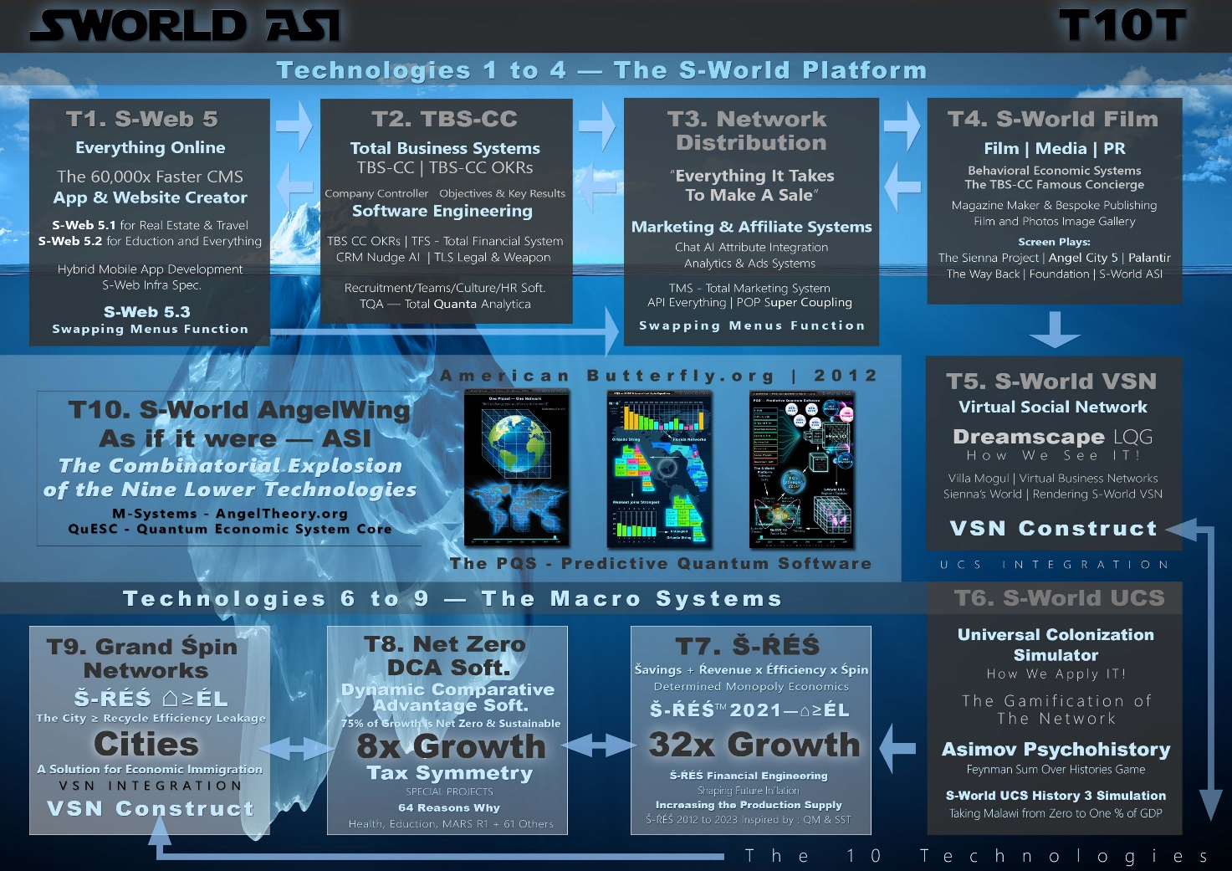

Noting the pace of development, in the graphic above we see no mention of S web 6 VC. I look forward to remaking the graphic, in early 2024, updating to the latest designs.
Thanks for reading
Nick Ray Ball
ℏ🚀🌀💙

S-Web 6VC~ℏ 🚀— 2024
2002 to 2024

Founder/CEO, and Owner
CAPE VILLAS LTD UK
www.CapeVillas.com
Company Number 1486 4994
Wren House, 5 Elm Grove, Epsom, Surrey, KT18 7LZ
Contact
+44 7387 394 298
CEO@CapeVillas.com

S-Web 6 VC🚀 | V🌀N

Nick Ray Ball
Founder/CEO, and CTO
S-World ASI LTD UK
www.S-World.org
Company Number 14929119
128 City Road
London, EC1V 2NX
Contact
+44 7387 394 298

S-World HEAI by Nick Ray Ball
1999 to 2023

Websites:
www.CapeVillas.com (2000 /23)
www.ExperienceAfrica.com (2009/23)
www.AmericanButterfly.org (2012)
www.CapeLuxuryVillas.com (2015/23)
http://Network.VillaSecrets.com (2017/18)
www.AngelTheory.org (2018)
www.Supereconomics.ai (2019)
www.S-Web.org (2020/23)
www.S-World.org (2020/23)
www.NickRayBall.com (2023)
Media
Twitter.com/NickRayBall
Linkedin.com/in/Nick-Ray-Ball
Facebook.com/NickRayBall

